**TODO LIST APP**

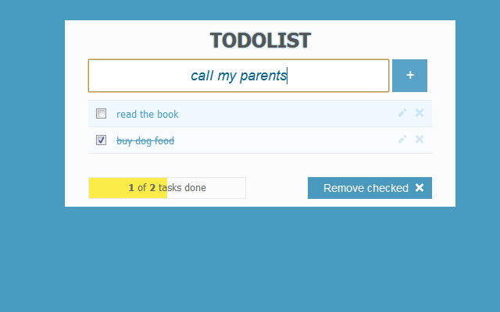**PROJECT DESCRIPTION**

Application objectives

To-do list is a list of errands and other tasks – often written on a piece of paper as a memory aid – that one needs or intends to accomplish.

User Stories and Planning

|  |  |
| --- | --- |
| **ITERATION** | **USER STORIES** |
| SPRINT 1 | Code Quality  * As a **Developer**, I want a development environment and GitHub repo set up * As a **Developer**, I want to be able to deploy the code so I can test it * As **Product Owner**, I want to be confident that the code is correct   + Make a test plan   + Make test data  User management  * As a **User**, I want to register an account * Email * Username * Password * As a **User**, I want to log in and out * As a **User**, I want to reset my password * As a **User**, I want to upload my profile image |
| SPRINT 2 | Manage Task ticket  * As a **User**, I want to list tasks * As a **User**, I want to see detail of my task   + title, description, label, deadline etc. * As a **User**, I want to add new task with some information   + Title   + Description   + Label   + Deadline * As a **User**, I want to edit my task * As a **User**, I want to delete my task * As a **User**, I want to check my task as DONE * As a **User**, I want to check progress of my tasks |